Regression Data Exam

Before we start to fit the full regression for the current coupon data, it is necessary to examine the variables (Current coupon, 2 yr swap, 10 yr swap, swap vol). So we can make sure the data quality (not many outliers), and the model assumption is feasible.
In our database we have the data set for all the parameters from 2006 to 2013.
- Exam the variable one at a time
This is done by graphically plotting out the predictors versus the current coupon data. Through this test, we can make sure that the data should not be too skewed, and check if the predictor has a liner relationship or possibly linearizable relationship.

- 10 year swap rate
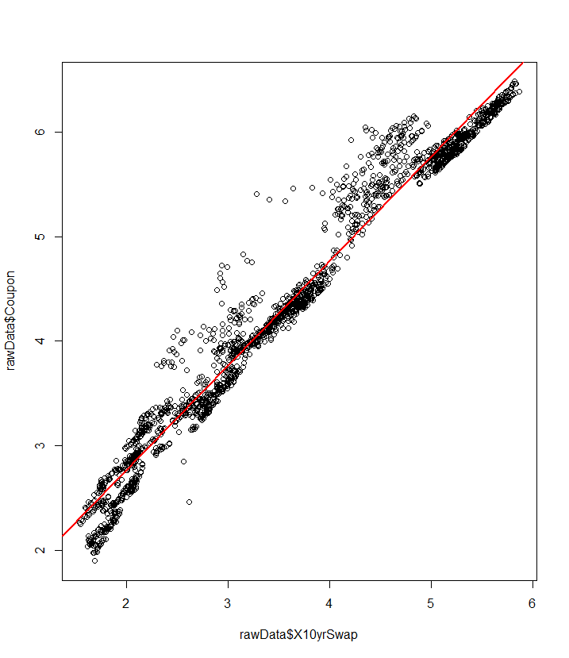
From the picture above, we can see a good linear relationship between 10 yr swap and current coupon rate, despite some of the outliers above the main data points.

- 2 year swap rate
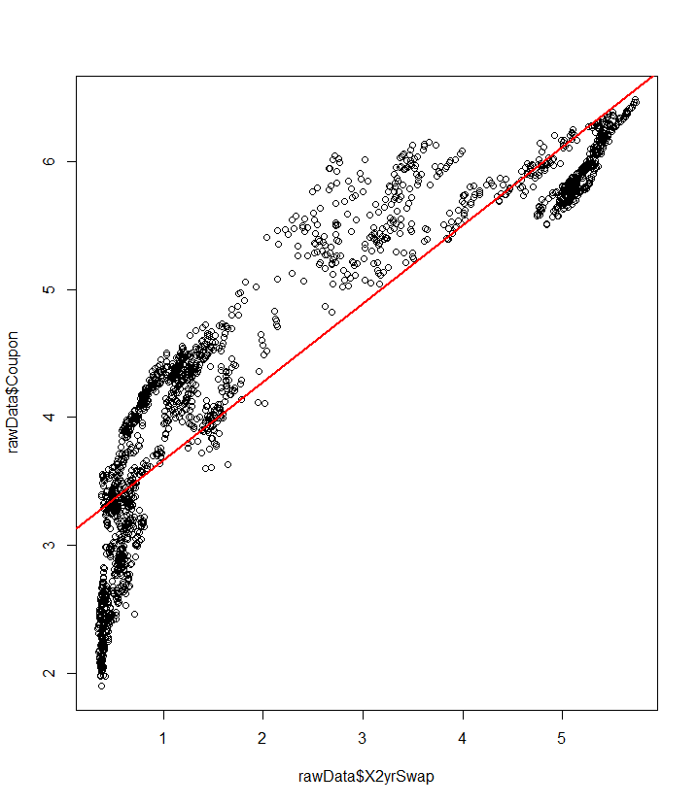
This picture suggests a nonlinear relationship, but we can see there might be a logarithmic relationship, which can be transform into linear. After the transform:
new 2yr swap = log(2 yr swap)
we get the result as below, we can see a better linear relationship in this picture:
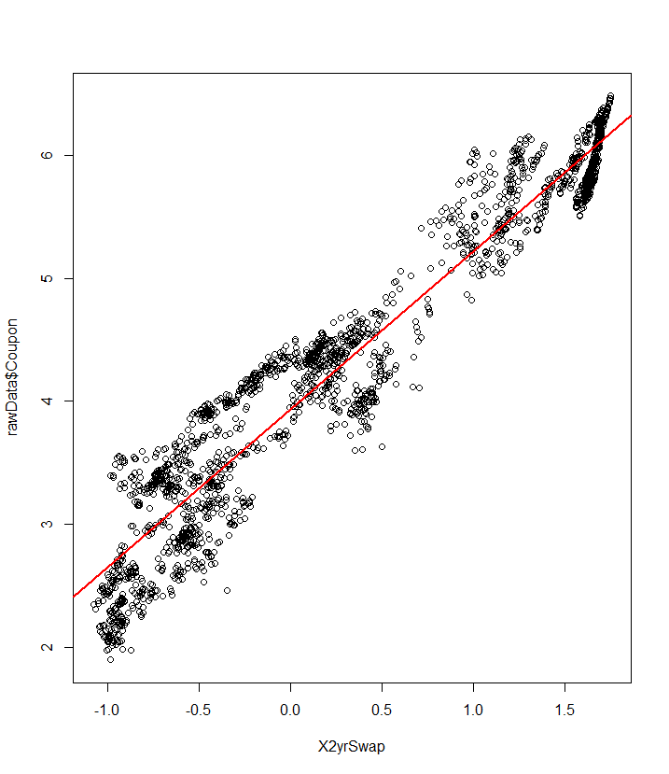
- Swap vol
From the below showed graph, there is a very poor linear relation between the swap vol data and current coupon. Instead, we find two linear parts within this chart – there is a linear distributed data set above coupon rate 5.0 and another one below that.
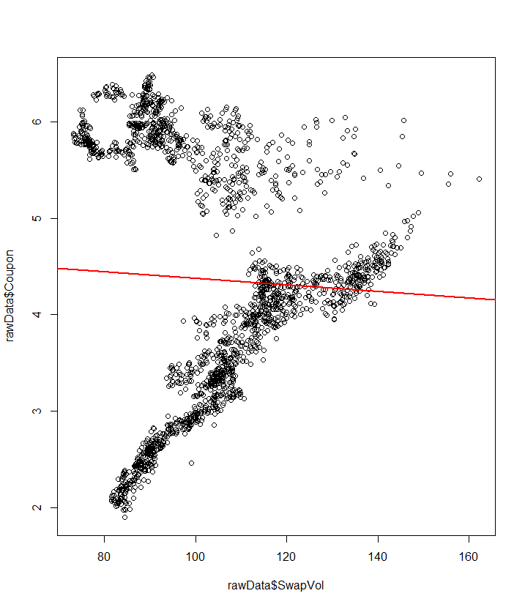
In order to figure out the reason, we investigated the data set on the time axis:
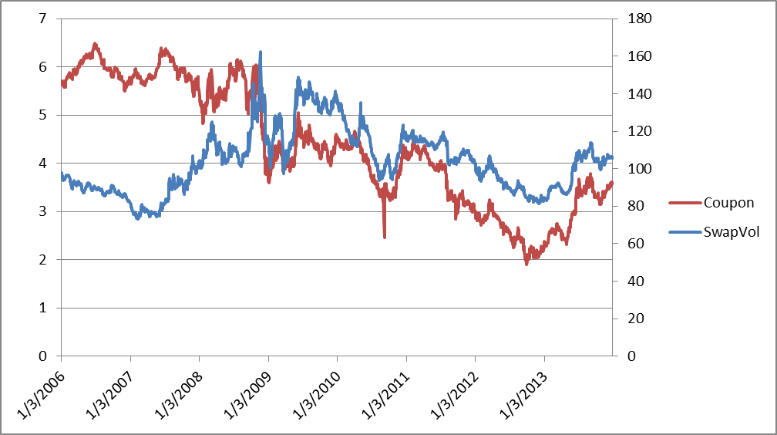
From it, we can see a negative correlation between the coupon rate and swap vol before 2009, and a positive correlation after that. An initial guess is the relationship between swap vol and coupon rate has been changed after the financial crisis. So we cut our data set from 2009 and did the plot between swap vol and coupon rate again:
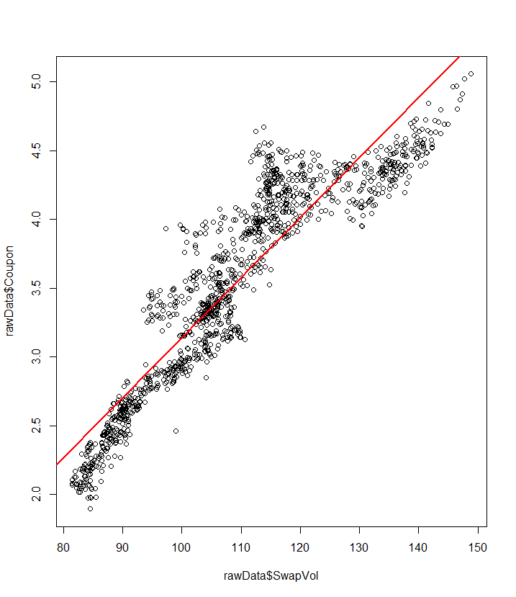
Clearly, we can see a perfect linear relationship.

One question we may ask is what about the other two variables if we cut the data to 2009? We did the similar test for them, and the results still maintain a good quality.
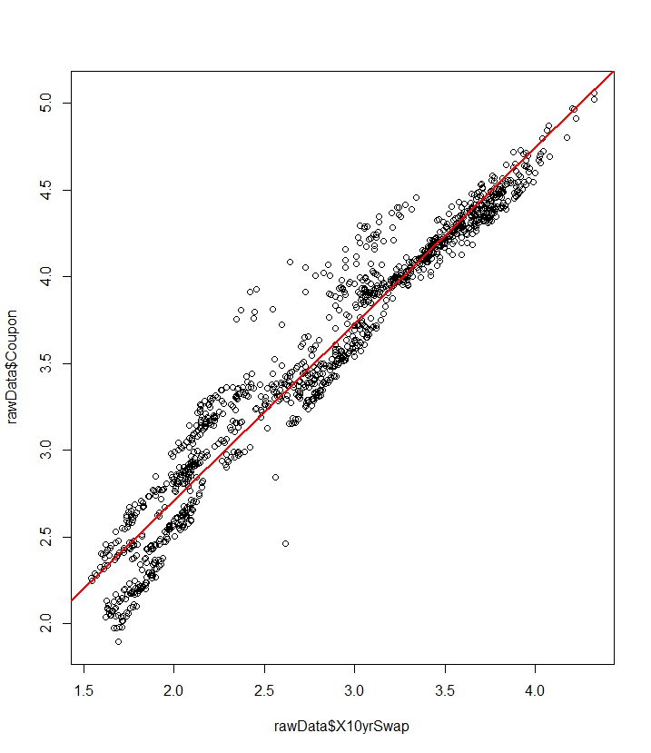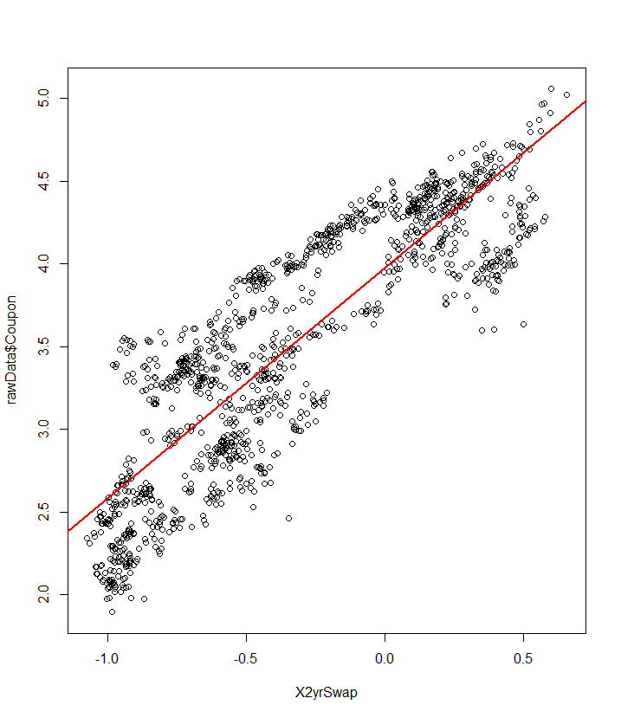
10 yr swap 2 yr swap

- Exam the collinearity
Interpretation of the multiple regression depends on the assumption that the predictor variables are not strongly correlated. The condition of severe non-orthogonality is also refer to multicollinearity. An easy we to test the collinear data problem is to calculate the correlation matrix or do a pairwise scatter plot. Here we did a pair plot upon each variable:
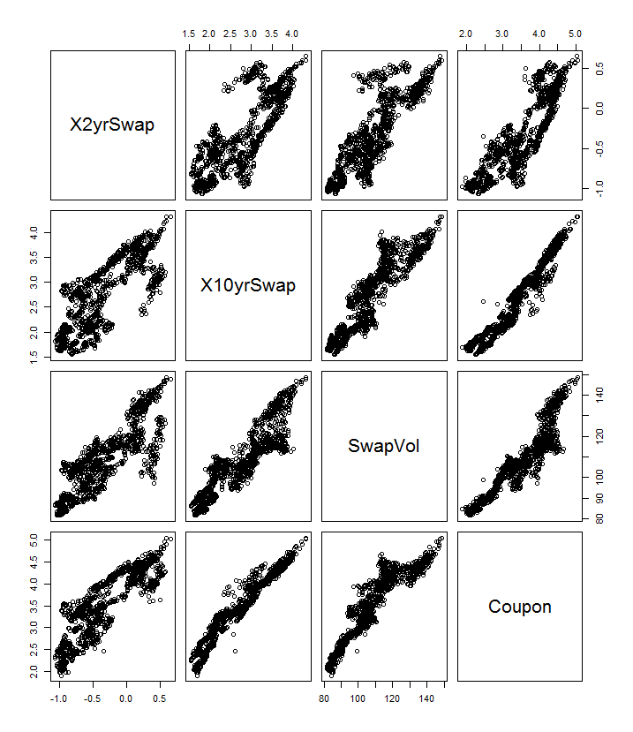
From the picture, we can see a significant positive correlation between each two parameters. So muticollinearity is expected in this case. It is not unreasonable to concluded there are not three variables but in fact only one.

